etrusca

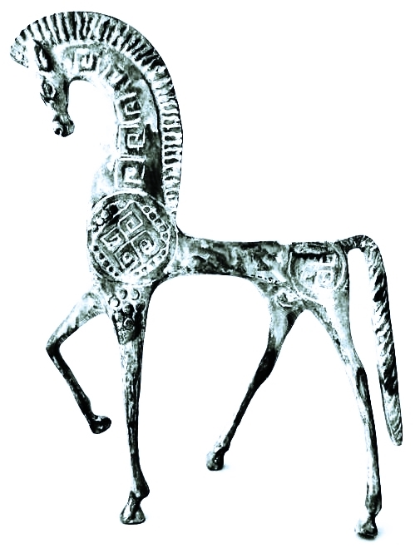

**2017 Paolo Pinot Noir|Mendocino Ridge**

**Vineyard**: The Perli Vineyard located in the Mendocino Ridge is a high elevation site, known as “islands in the sky” due to the location in the clouds and above the fog line, seemingly creating formations that encircle the vineyards and surrounding terrain in what appears to be islands in the sky when viewed from above. The unique terroir produces delicate yet intensely flavored fruit. Due to the combination of soil, cooler climate and long periods of basking in the sunshine, the vineyard consistently produces exquisitely flavored, exceptional wines.

**Vintage**: The 2017 vintage offered excellent growing conditions. Winter rains replenished groundwater and reservoirs. The moderate to warm weather conditions contributed to early ripening for the low yields, and resulted in highly concentrated grapes of exceptional quality.

**Fermentation**: Fermentations conducted in open top, stainless steel tanks with manual punch downs four times daily. Using only indigenous yeasts/malolactic cultures for primary and secondary fermentation, we make efforts to capture the sense of place. Wines are pressed just before going dry to preserve supple phenolic structure as well as allowing for some barrel fermentation for a seamless harmony with the oak. All wine movements are gentle, by gravity.

**Sensory Notes:** This 2017 Etrusca Paolo Pinot Noir is a pale garnet in color, the nose is full of crushed cranberries, strawberry and spiced orange peel. The texture is silky, and the palate shows exuberant cherry, strawberry and Autumn spices. Notes of berries and nutmeg lead to a long lasting and pleasant finish.

Cooperage & Aging: Aged in 100% French oak cooperage (50% new)

Aging Regimen: 10 months.

Production: 2 barrels